Perform the task in today's lecture.
Task1: Using Handlebar, create HTML page that contains following information
- Subject-Code, Subject-Name (Text-box)
- Institute-Name (Text-box)
- Department-Name (Text-box)
- Semester=>Dropdown menu
Task2: Store above information into MySQL database and display
File- Structure: -
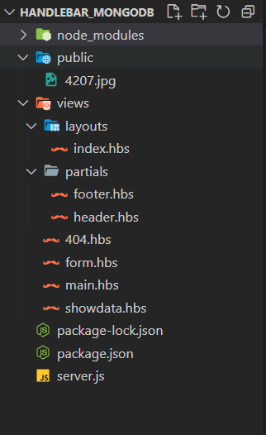
Code: -
- server.js
const express=require("express");
const PORT=3000;
const app=express();
const handlebars=require("express-handlebars");

var mysql = require('mysql');
//connection
const connection = mysql.createConnection({
host: 'localhost',
user:'root',
password:'',
});

connection.connect((err)=>{
if(err) throw err;
console.log("Connected successfully to MySql server")
});

//create database
const dbquery="CREATE DATABASE IF NOT EXISTS Subject";

connection.query(dbquery,(err,result)=>{
if(err) throw err;
console.log("Database created successfully",result)
})
//create table
const dbtable=`CREATE TABLE IF NOT EXISTS subject(
subjectCode varchar(10) NOT NULL,
subjectName varchar(50) NOT NULL,
instituteName varchar(50) NOT NULL,
departmentName varchar(50) NOT NULL,
semester varchar(1) NOT NULL,
PRIMARY KEY (subjectCode))`

// SHOW DATABASES => List the available DB from MySql server

connection.query("USE Subject",(err,result)=>{ // "Select Database"
if(err) throw err;
connection.query(dbtable,(err,result)=>{
if(err) throw err;
console.log("Table created successfully",result)
});
});

//middleware
app.use(express.static("public"));
app.use(express.urlencoded({extended:false}));

app.set('view engine', 'hbs');

app.engine("hbs",handlebars({
layoutsDir:`${__dirname}/views/layouts`,
extname:"hbs",
defaultLayout:"index",
partialsDir:`${__dirname}/views/partials`
}))

app.get("/",(req,res)=>{
res.render("main");
});

app.get("/subject-form",(req,res)=>{
res.render("form");

});

app.post("subject-form",(req,res)=>{

res.redirect("/show-data")

});
app.post("/show-data",(req,res)=>{
// console.log(req.body);

var subjectCode = req.body.scode;
var subjectName = req.body.sname;
var instituteName = req.body.iname;
var departmentName = req.body.dname;
var semester=req.body.sem;

var sql = `INSERT INTO subject (subjectCode, subjectName, instituteName, departmentName, semester) VALUES ("${subjectCode}", "${subjectName}", "${instituteName}", "${departmentName}","${semester}")`;
connection.query(sql, function(err, result) {
if (err) throw err;
console.log('record inserted');

res.render("showdata",{data:req.body});
});

})

app.get("/stored-data",(req,res)=>{

const dbInsert=`SELECT * from subject`;

connection.query("USE Subject",(err,result)=>{
if(err) throw err;
connection.query(dbInsert,(err,result)=>{
if(err) throw err;

console.log("Inserted Data is");
console.log(result);
res.send(result);
})
})
})

app.use( (req,res,next)=>{
res.render("404");
})

app.listen(PORT,()=>{
console.log(`Server is listening on port ${PORT}`);
})

- views/layouts/index.hbs
<!DOCTYPE html>
<html lang="en">
<head>
<meta charset="UTF-8">
<meta http-equiv="X-UA-Compatible" content="IE=edge">
<meta name="viewport" content="width=device-width, initial-scale=1.0">

<link
rel="stylesheet"
href="https://bootswatch.com/5/sketchy/bootstrap.min.css"
/>
<script src="https://bootswatch.com/_vendor/bootstrap/dist/js/bootstrap.bundle.min.js"></script>
<script src="https://bootswatch.com/_vendor/jquery/dist/jquery.min.js"></script>

<script src="https://kit.fontawesome.com/fd15636b22.js" crossorigin="anonymous"></script>
<title>MongoDB-NodeJS</title>
</head>

<style>
.mainbox {
margin: 2rem auto;
text-align: center;
}
body{
/* background-color: #ffffff;
background-image: url("data:image/svg+xml,%3Csvg xmlns='http://www.w3.org/2000/svg' width='100' height='100' viewBox='0 0 100 100'%3E%3Cg stroke='%23CCC' stroke-width='0' %3E%3Crect fill='%23F5F5F5' x='-60' y='-60' width='110' height='240'/%3E%3C/g%3E%3C/svg%3E"); */

background-color: #ffffff;
background-image: url("data:image/svg+xml,%3Csvg xmlns='http://www.w3.org/2000/svg' viewBox='0 0 1600 900'%3E%3Cdefs%3E%3ClinearGradient id='a' x1='0' x2='0' y1='1' y2='0'%3E%3Cstop offset='0' stop-color='%230FF'/%3E%3Cstop offset='1' stop-color='%23CF6'/%3E%3C/linearGradient%3E%3ClinearGradient id='b' x1='0' x2='0' y1='0' y2='1'%3E%3Cstop offset='0' stop-color='%23F00'/%3E%3Cstop offset='1' stop-color='%23FC0'/%3E%3C/linearGradient%3E%3C/defs%3E%3Cg fill='%23FFF' fill-opacity='0' stroke-miterlimit='10'%3E%3Cg stroke='url(%23a)' stroke-width='2'%3E%3Cpath transform='translate(0 0)' d='M1409 581 1450.35 511 1490 581z'/%3E%3Ccircle stroke-width='4' transform='rotate(0 800 450)' cx='500' cy='100' r='40'/%3E%3Cpath transform='translate(0 0)' d='M400.86 735.5h-83.73c0-23.12 18.74-41.87 41.87-41.87S400.86 712.38 400.86 735.5z'/%3E%3C/g%3E%3Cg stroke='url(%23b)' stroke-width='4'%3E%3Cpath transform='translate(0 0)' d='M149.8 345.2 118.4 389.8 149.8 434.4 181.2 389.8z'/%3E%3Crect stroke-width='8' transform='rotate(0 1089 759)' x='1039' y='709' width='100' height='100'/%3E%3Cpath transform='rotate(0 1400 132)' d='M1426.8 132.4 1405.7 168.8 1363.7 168.8 1342.7 132.4 1363.7 96 1405.7 96z'/%3E%3C/g%3E%3C/g%3E%3C/svg%3E");
background-attachment: fixed;
background-size: cover;

}

.navbar{
margin: 0.5rem 0.5rem;

}
</style>

<body>
{{> header}}
{{{body}}}
{{>footer}}

</body>
</html>

- views/partials/header.hbs
<nav class="navbar navbar-expand-lg navbar-dark bg-primary ">
<div class="container-fluid">
<a class="navbar-brand" href="/">MongoDB-NodeJS</a>
<button class="navbar-toggler" type="button" data-bs-toggle="collapse" data-bs-target="#navbarColor01" aria-controls="navbarColor01" aria-expanded="true" aria-label="Toggle navigation">
<span class="navbar-toggler-icon"></span>
</button>

<div class="navbar-collapse collapse show" id="navbarColor01">
<ul class="navbar-nav mx-auto text-md-center text-left">
<li class="nav-item">
<a class="nav-link active" href="/">Home
</a>
</li>
<li class="nav-item">
<a class="nav-link " href="/subject-form">SubjectForm</a>
</li>
<li class="nav-item">
<a class="nav-link " href="/stored-data">Stored-Datas</a>
</li>

</ul>
</div>
</div>
</nav>

- views/partials/footer.hbs
<!-- footer Section -->

<style>
.foot{
margin-top: 0%;
}
</style>

<footer class="navbar-static-bottom foot">
<div class="container-fluid">
<p class="text-center p-4">© Copyright 2021 Jaydipsinh Padhiyar</p>
</div>
</footer>
</body>

</html>
- views/form.hbs

<class class="container mainbox">
<div class="row justify-content-md-center">
<div class="col-12">
<h1>ADD SUBJECT DETAILS</h1>
</div>

<div class="col-8" style="margin: 2rem;padding: 5rem;">
<form name="subject-form" action="/show-data" method="post" class="row g-2" >
<div class="col-md-6">
<label for="subject_code" class="form-label">Subject Code</label>
<input type="text" class="form-control" name="scode" id="subject_code" maxlength="10" required>
</div>

<div class="col-md-6">
<label for="subject_name" class="form-label">Subject Name</label>
<input type="text" class="form-control" name="sname" id="subject_name" required>
</div>

<div class="col-md-6">
<label for="institute_name" class="form-label">Institute Name</label>
<input type="text" class="form-control" name="iname" id="institute_name" required>
</div>

<div class="col-md-6">
<label for="department_name" class="form-label">Department Name</label>
<input type="text" class="form-control" name="dname" id="department_name" required>
</div>

<div class="col-md-8">
<label for="sem" class="form-label">Semester</label>
<select class="form-select" name="sem" id="sem" aria-describedby="sem" required>
<option selected disabled value="">Choose</option>
<option>1</option>
<option>2</option>
<option>3</option>
<option>4</option>
<option>5</option>
<option>6</option>
<option>7</option>
<option>8</option>
</select>
</div>

<div class="col-12">
<button class="btn btn-primary" type="submit">Submit form</button>
</div>

</div>
</form>
</div>

</class>

- views/main.hbs
<div class="row justify-content-md-center">
<div class="col-md-auto">
<h1>MongoDB-NodeJS</h1>
</div>
</div>

<div class="row justify-content-md-center">
<div class="d-flex justify-content-center">
<div class="col-6">
<img
class="text-center"
src="4207.jpg"
alt="Welcome Image"
style="width:90%;"
/>
</div>

<div class="col-6">
<div class="card border-info mb-3" style="max-width: 30rem;margin: 15rem 10rem;">
<div class="card-header">Add Subject Info</div>
<div class="card-body">
<p class="card-text">
Click below button fill your subject details.
</p>
<h4 class="card-title">
<a class="btn btn-info" href="/subject-form">Add Subject</a>
</h4>

</div>
</div>
</div>
</div>

</div>

- view/showdata.hbs
<style>
table, th, td {
border: 1px solid black;
margin-top:20%;
}

</style>

<div class="row justify-content-md-center">
<h1 style="text-align: center; margin-top:5%">Submitted Subject Data</h1>
</div>

<div class="row justify-content-md-center">

<div class="col-md-6">
<table class="table" >

<tr>

<th scope="col">Subject Code</th>
<td>{{data.scode}}</td>
</tr>

<tr>
<th scope="col">Subject Name</th>
<td>{{data.sname}}</td>
</tr>

<tr>
<th scope="col">Institute Name</th>
<td>{{data.iname}}</td>
</tr>

<tr>
<th scope="col">Department Name</th>

<td>{{data.dname}}</td>
</tr>

<tr>
<th scope="col">Semester</th>
<td>{{data.sem}}</td>
</tr>

</table>
</div>
</div>

- views/404.hbs
<!DOCTYPE html>
<html lang="en">

<head>
<meta charset="utf-8">
<meta http-equiv="X-UA-Compatible" content="IE=edge">
<meta name="viewport" content="width=device-width, initial-scale=1">

<title>404</title>

<!-- Google font -->
<link href="https://fonts.googleapis.com/css?family=Cabin:400,700" rel="stylesheet">
<link href="https://fonts.googleapis.com/css?family=Montserrat:900" rel="stylesheet">

</head>

<style>
* {
-webkit-box-sizing: border-box;
box-sizing: border-box;
}

body {
padding: 0;
margin: 0;
}

#notfound {
position: relative;
height: 100vh;
}

#notfound .notfound {
position: absolute;
left: 50%;
top: 50%;
-webkit-transform: translate(-50%, -50%);
-ms-transform: translate(-50%, -50%);
transform: translate(-50%, -50%);
}

.notfound {
max-width: 520px;
width: 100%;
line-height: 1.4;
text-align: center;
}

.notfound .notfound-404 {
position: relative;
height: 240px;
}

.notfound .notfound-404 h1 {
font-family: 'Montserrat', sans-serif;
position: absolute;
left: 50%;
top: 50%;
-webkit-transform: translate(-50%, -50%);
-ms-transform: translate(-50%, -50%);
transform: translate(-50%, -50%);
font-size: 252px;
font-weight: 900;
margin: 0px;
color: #262626;
text-transform: uppercase;
letter-spacing: -40px;
margin-left: -20px;
}

.notfound .notfound-404 h1>span {
text-shadow: -8px 0px 0px #fff;
}

.notfound .notfound-404 h3 {
font-family: 'Cabin', sans-serif;
position: relative;
font-size: 16px;
font-weight: 700;
text-transform: uppercase;
color: #262626;
margin: 0px;
letter-spacing: 3px;
padding-left: 6px;
}

.notfound h2 {
font-family: 'Cabin', sans-serif;
font-size: 20px;
font-weight: 400;
text-transform: uppercase;
color: #000;
margin-top: 0px;
margin-bottom: 25px;
}

@media only screen and (max-width: 767px) {
.notfound .notfound-404 {
height: 200px;
}
.notfound .notfound-404 h1 {
font-size: 200px;
}
}

@media only screen and (max-width: 480px) {
.notfound .notfound-404 {
height: 162px;
}
.notfound .notfound-404 h1 {
font-size: 162px;
height: 150px;
line-height: 162px;
}
.notfound h2 {
font-size: 16px;
}
}

</style>

<body>

<div id="notfound">
<div class="notfound">
<div class="notfound-404">
<h3>Oops! Page not found</h3>
<h1><span>4</span><span>0</span><span>4</span></h1>
</div>
<h2>we are sorry, but the page you requested was not found</h2>
</div>
</div>

</body>

</html>

Output: -
- Server:
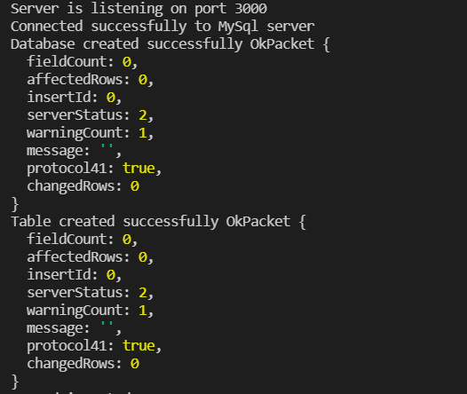
- localhost:3000/
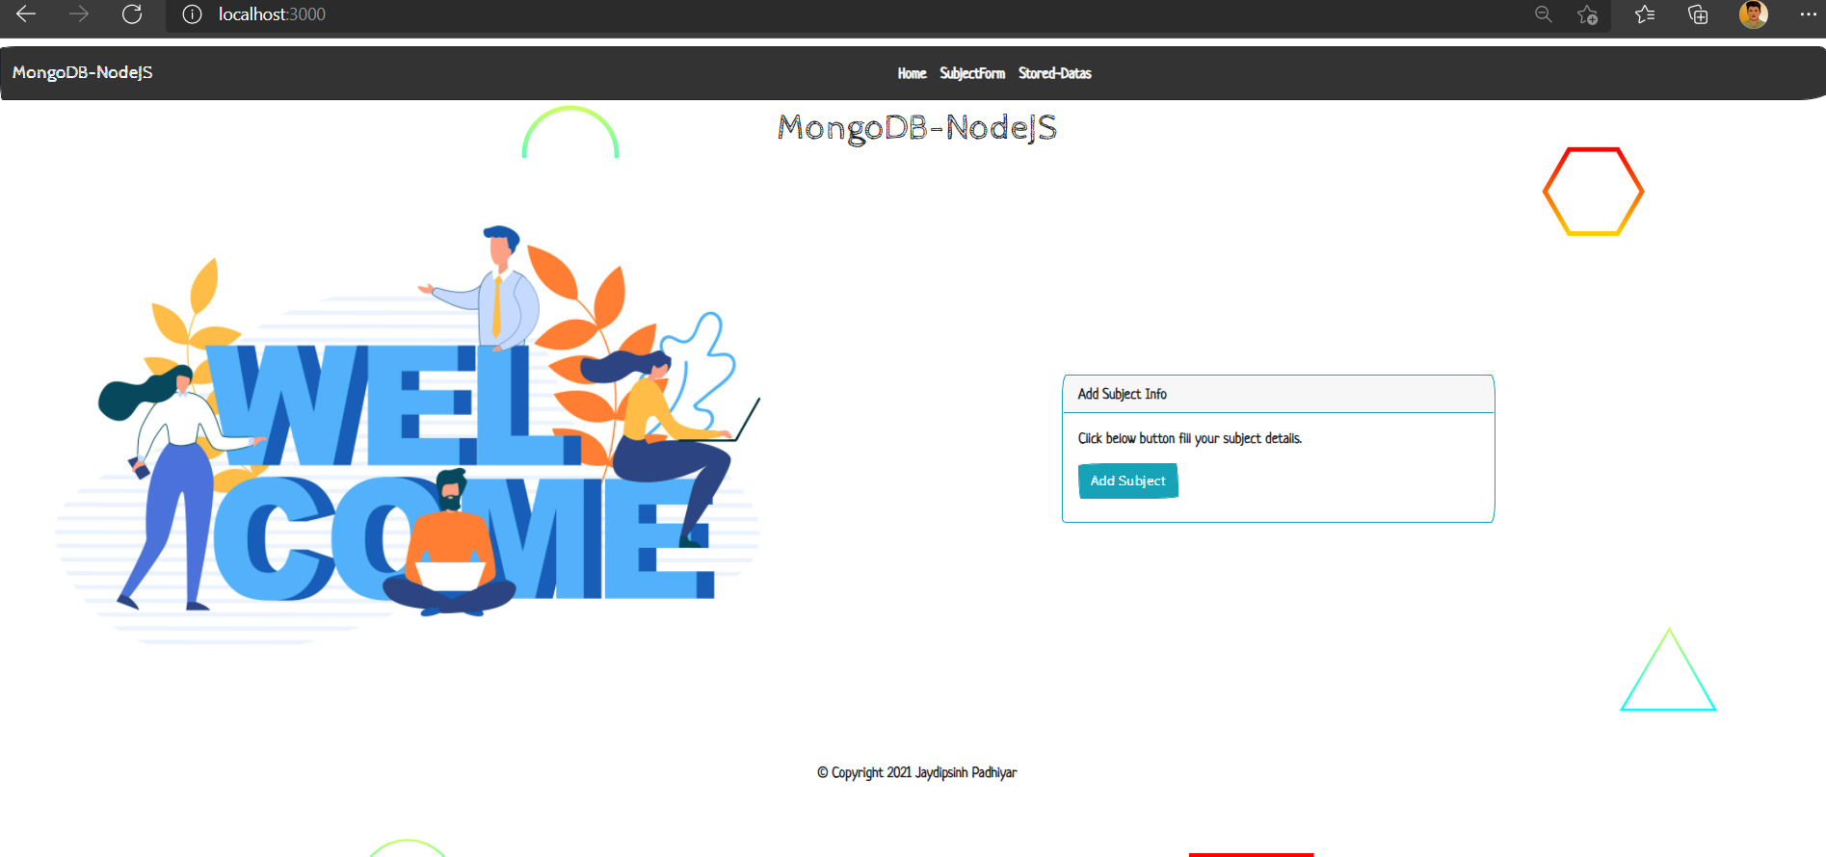

- localhost:3000/subject-form

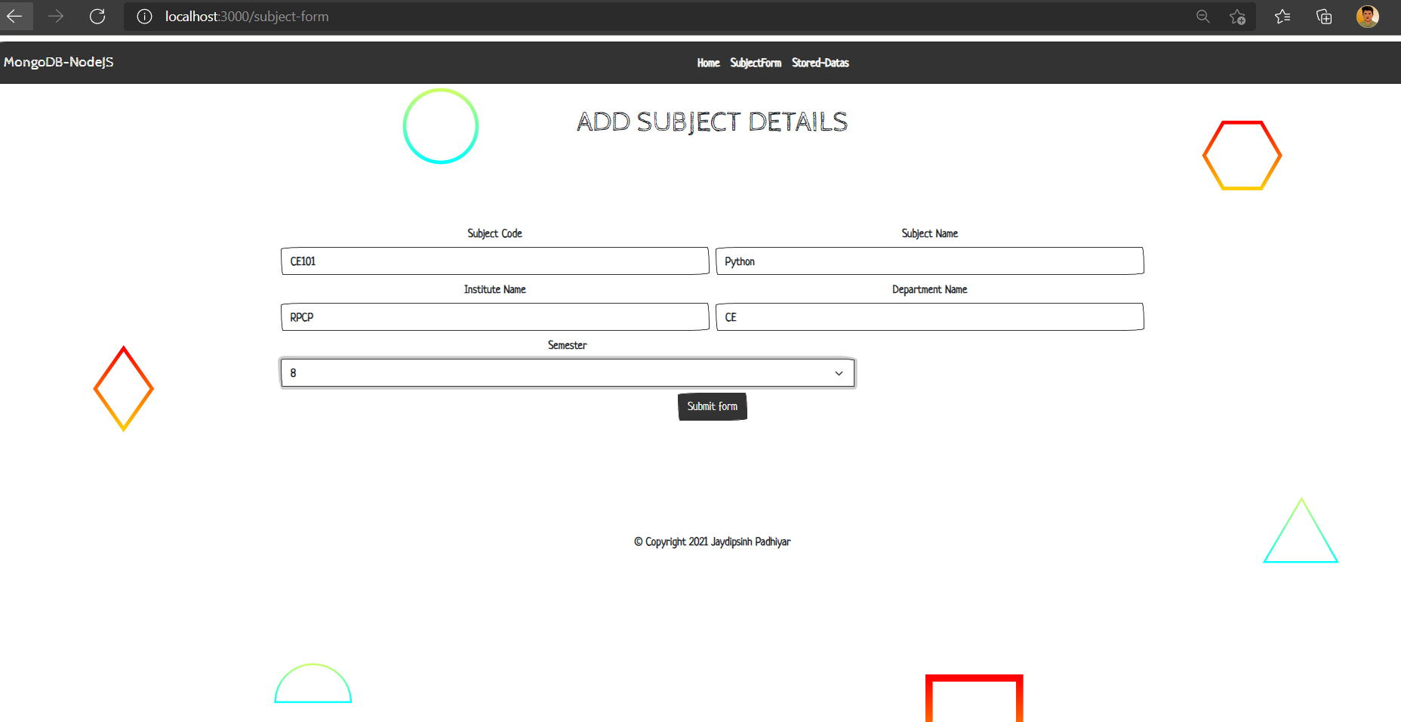

- localhost:3000/show-data
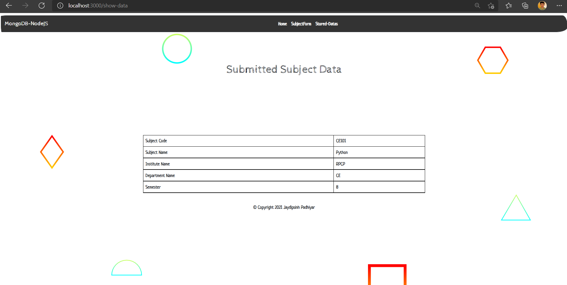

- localhost:3000/stored-data
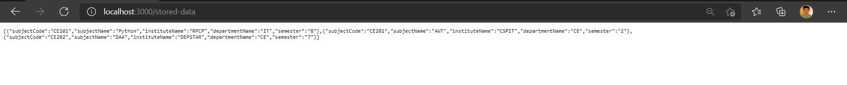

- MySQL phpmyadmin database:
